Introduction
In 2023, approximately 12.2 million adults experienced food insecurity.¹ Food insecurity in the United States is one of the leading social determinants of health that can heighten an individual’s risk for chronic and diet-related diseases such as cardiovascular disease, diabetes, and certain cancers.^{2,3} On average, about one-third of households with very low food security experience chronic food insecurity, lasting roughly eight months per year.⁴ These significant patterns reveal the persistent and widespread nature of food insecurity and its relevance to the populations’ health. Food security is defined as “the reliable access to adequate food for a healthy lifestyle.”¹ On the other hand, food insecurity refers to limited or uncertain access due to financial or resource constraints. Approximately 17.9 million households in the United States were considered food insecure in 2023.⁴ Food security is one of the social determinants of health that can perpetuate numerous health disparities within vulnerable populations.^{5,6} Existing literature has found that structural inequities such as systemic racism, economic disadvantage, and neighborhood-level barriers contribute to low food security among households.^{5–7} Disparities within food insecurity persist, as marginalized populations such as Non-Hispanic Black and Hispanic households often face food insecurity due to racial and socioeconomic disparities, with consistently higher rates compared to Non-Hispanic White households.^{6,8} These inequities reflect broader social and economic conditions that contribute to enduring health disparities.
There is consistent evidence in the literature that households facing environmental conditions such as inaccessibility to high-quality produce and the economic burden of affording foods with nutritional value are more vulnerable to experiencing food insecurity.^{6,9} Food insecurity often leads to changes in both the quantity and quality of food consumed, with households facing limited access to fresh, whole foods and relying more heavily on packaged, processed, and shelf-stable items.^{4,9,10}. Previous literature has examined the complex relationship between food security, diet, and one’s built environment, demonstrating that food insecurity is closely linked to poorer dietary quality and greater intake of ultra-processed foods.¹⁰
Phenols are a class of organic chemical compounds characterized by one or more hydroxyl groups attached to an aromatic hydrocarbon ring.¹¹ These chemicals are widely used in the manufacturing of common household items, food packaging, and food preservatives.^{10,12} As a result, humans are exposed to phenols through multiple pathways, including inhalation, ingestion, and skin contact.^{10,13,14} Studies have examined the connection between phenol exposure and diet, showing the consumption of ultra-processed foods can be associated with higher urinary concentrations of several phenols.^{10,13–16}
Despite these findings, a key research gap remains in understanding the chemical exposure pathways linking household food insecurity and endocrine disrupting chemicals, specifically phenol metabolite exposures. Understanding this connection is important for identifying environmental health disparities and the broader health impacts of household food insecurity.¹⁷ This study analyzes the extent of the association between household food insecurity and urinary phenol metabolite concentrations through a cross-sectional design using National Health and Nutrition Examination Survey data from cycle years 2005 to 2016. This study aims to investigate the association between household food security and urinary phenol concentrations among NHANES participants and to assess whether race/ethnicity and sex modify this association. We hypothesized that decreasing food security will be associated with increased urinary phenol metabolite concentrations among adults, and that sex and race/ethnicity will modify these associations.
Methods

Study Design
This study utilized cross sectional data from the National Health and Nutrition Examination Survey (NHANES), a US based population.¹⁸ NHANES is administered through the Centers of Disease Control and Prevention (CDC), and conducts interviews, physical examinations and laboratory tests on a random sample of eligible study participants, utilizing one participant from each household.^{18,19} NHANES uses a complex, multistage sampling method with oversampling of selected population subgroups. Details on data collection is made available elsewhere.^{18,19}
We utilized data from the 2005-2016 NHANES cycle years, where phenols of interest were consistently measured. Individuals were eligible for inclusion in our study if they were 18 years of age or older, had available urinary phenol metabolite, household food security, and sociodemographic information. The initial study population consisted of 18,961 participants; we excluded children (n=5,754) with our final analytic study cohort of 10,094 adult participants (n=10,094) (Supplemental Figure 1).
Household Food Security
Household food security was measured using the U.S. Department of Agriculture’s (USDA) Food Security Survey Module (FSSM), a well-validated 18-item questionnaire.²⁰ Questionnaires were administered in participant’s home by an NHANES personnel, using computer assisted personal interview technology.^{18,21} Based on the survey module’s responses, a categorical variable was created with four household food security categories: high food security (reference), marginal food security, low food security, and very low food security.²⁰ For the remainder of this paper, we will simply refer to food security levels as high, marginal, low, and very low food security.
Urinary Phenol Metabolite Concentrations
NHANES measured urinary phenol metabolite concentrations (ng/mL) by collecting spot urine samples, assayed by the CDC National Center for Environmental Health Laboratory, utilizing solid phase extraction in conjunction with high performance liquid chromatography electrospray ionization tandem mass spectrometry (HPLC-ESI-MS/MS)27.²² Given the rapid metabolism and urinary excretion of phenols, urinary phenol metabolites were assessed as biomarkers of exposure to the parent compounds, thereby minimizing exposure misclassification.^{11,23,24} We initially identified nine urinary phenol metabolites for the study analysis and removed metabolites that were not consistently found across cycle years or had detection frequencies below 50%. As a result we restricted to six urinary phenol metabolites measured across 2005-2016 cycle years: urinary Bisphenol A (BPA), urinary 2-Hydroxy-4-methoxybenzophenone or benzophenone-3 (BP3), urinary 2,4,4’-Trichloro-2’-hydroxyphenyl ether or Triclosan (TRS), urinary Ethyl Paraben (EPB), urinary Methyl Paraben (MPB), and urinary Propyl Paraben (PPB). Values below the LOD were substituted with LLOD$√$2 by NHANES.

Covariates

Covariates were identified a priori using existing literature^{10,24,25} and directed acyclic graphs (DAGs) to identify potential confounders of the association between urinary phenol metabolite concentrations and household food security. Covariate data were obtained from computer-assisted demographic questionnaires administered by NHANES personnel.¹⁸ We included age, sex, race/ethnicity, highest educational attainment, and poverty income ratio (PIR) as covariates of interest. PIR is calculated by NHANES using U.S. Department of Health and Human Services poverty guidelines¹⁸. We additionally created survey cycle year as a categorical variable to account for temporal differences across cycles.²⁶ Urinary creatinine concentration (ng/mL) was included to adjust for urinary dilution, consistent with prior NHANES-based analyses.²³

Statistical Analysis
Descriptive statistics including frequencies (percentages) and means were calculated to analyze the analytic study populations’ sociodemographic factors and other covariate groups by food security status. Urinary phenol metabolite concentrations were log normally distributed and were natural log transformed. Detection percentages, geometric means (GM) and the 25th and 75th percentile were reported. Spearman correlation coefficients were used to assess correlations between individual metabolites. For our main analysis we used multivariable linear regression models to evaluate the association between log transformed urinary phenol concentrations and food security levels. We first ran urinary creatinine-adjusted models only followed by models adjusted for our confounders of interest. Covariates in fully adjusted models were defined according to their NHANES categorization: sex (female (ref), male), education level (< 9th grade, high school graduate or equivalent, some college, ≥ college), age (continuous), race/ethnicity (non-Hispanic White (ref), non-Hispanic Black, Mexican American, other Hispanic, Other including Multi-Racial), poverty income ratio (0-0.99, 1-1.99, 2-2.99, 3-4.99, and 5.0 or greater). We also included a generated cycle year variable (2005-2006, 2007-2008, 2009-2010, 2011-2012, 2013-2014, and 2015-2016) as well as measured urinary creatinine. Exponentiated estimated coefficients were presented as the percent (%) difference, computed as 100*(exp(β)-1). Higher concentrations in the comparison group (marginal, low, and very low food security) to the reference group (high food security) indicated a positive percent differences; negative percent differences indicated lower concentrations.
To assess potential effect measure modification by sex, race, and ethnicity, household food security was modeled categorically as a nominal variable with a product term for household food security status*sex and household food security*race and ethnicity respectively. Estimated adjusted marginal means were extracted and reported as percent differences by sex or race and ethnicity. Next, to test for overall interaction, and obtain a p_{interaction} for each analyte, we modeled the four-level household food security variable as an ordinal variable, with a single cross-product term, assuming equal spacing between categories and linear trends across categories. We then examined whether these linear trends across ordinal categories of household food security, differed by sex or race and ethnicity for each analyte. We used a conservative p-value of $<$0.10 for statistical significance. All statistical analyses were performed in R studio 4.5.1.

 | Full (Ref)  N=7,019 | Marginal  N=1,136 | Low  N=1,218 | Very Low  N=721 | Overall  (N=10,094)
 | N (%) | N (%) | N (%) | N (%) | N (%)
Sex
Male | 3509 (50) | 533 (46.9) | 569 (51.5) | 569 (46.7) | 4,954 (49.1)
Female | 3,510 (50.0) | 603 (53.1) | 649 (53.3) | 378 (52.4) | 5,140 (50.9)
Age (years) | 49 (19) | 42 (18) | 42 (17) | 42 (16) | 47 (19)
Race/Ethnicity
NH White | 3,412 (48.6) | 345 (30.4) | 318 (26.1) | 250 (34.7) | 4,325 (42.8)
NH Black | 1,441 (20.5) | 297 (26.1) | 331 (27.2) | 194 (26.9) | 2,263 (22.4)
Mexican-American | 868 (12.4) | 267 (23.5) | 294 (24.1) | 139 (19.3) | 1,568 (15.5)
Other Hispanic | 520 (7.4) | 126 (11.1) | 165 (13.5) | 95 (13.2) | 906 (9.0)
Other, incl. Multi-Racial | 778 (11.1) | 101 (8.9) | 110 (9.0) | 43 (6.0) | 1,032 (10.3)
Highest Educational Attainment
Less than 9th Grade | 1,382 (19.7) | 396 (34.9) | 504 (41.4) | 284 (39.4) | 2,566 (25.4)
High School Graduate or Equivalent | 1,730 (24.6) | 320 (28.2) | 327 (26.8) | 197 (27.3) | 2,574 (25.5)
Some College | 1,939 (27.6) | 313 (27.6) | 303 (24.9) | 210 (29.1) | 2,756 (27.4)
College or Above | 1,968 (28.0) | 107 (9.4) | 84 (6.9) | 30 (4.2) | 2,189 (21.7)
Poverty Income Ratio
Low Poverty | 993 (14.1%) | 397 (34.9%) | 528 (43.3%) | 375 (52.0%) | 2,293 (22.7%)
Near Poverty | 1,560 (22.2%) | 405 (35.7%) | 458 (37.6%) | 262 (36.3%) | 2,685 (26.6%)
Middle Income | 1,085 (15.5%) | 178 (15.7%) | 127 (10.4%) | 53 (7.4%) | 1,443 (14.3%)
Upper-Middle Income | 1,679 (23.9%) | 124 (10.9%) | 91 (7.5%) | 27 (3.7%) | 1,921 (19.0%)
High Income | 1,702 (24.2%) | 32 (2.8%) | 14 (1.1%) | 4 (0.6%) | 1,752 (17.4%)
Cycle Year
2005–2006 | 1,179 (16.8) | 154 (13.6) | 148 (12.2) | 70 (9.7) | 1,551 (15.4)
2007–2008 | 1,313 (18.7) | 175 (15.4) | 168 (13.8) | 93 (12.9) | 1,749 (17.3)
2009–2010 | 1,246 (17.8) | 197 (17.3) | 234 (19.2) | 148 (20.5) | 1,825 (18.1)
2011–2012 | 1,109 (15.8) | 195 (17.2) | 192 (15.8) | 127 (17.6) | 1,623 (16.1)
2013–2014 | 1,203 (17.1) | 199 (17.5) | 218 (17.9) | 138 (19.1) | 1,758 (17.4)
2015–2016 | 969 (13.8) | 216 (19.0) | 258 (21.2) | 145 (20.1) | 1,588 (15.7)

Table 1: Unweighted Demographic Characteristics of the Analytic Study Population
- Unweighted descriptive statistics count (frequency) and proportion (percentage) per food security category reported.

Study Population
A total of 10,094 adults were included in the final analytic study (Table 1). Participants were approximately evenly distributed by sex (male 49.1%, female: 50.9%). The median age was 47 years overall; adults with reduced food security (marginal, low and very low) were on average younger (n=42 years) than those with high food security (n=49 years). Non-Hispanic White adults were the largest racial/ethnic group overall (42.8%), followed by Non-Hispanic Black (22.4%) and Mexican American (15.5%). but were distributed differently across food security categories. Among adults with low food security, non-Hispanic Black (27.2%) and Mexican- American (24.1%) participants represented the largest proportions, whereas non-Hispanic White adults remained the largest group in high, marginal and very low categories. Participants with marginal, low and very low security had lower educational attainment, with a higher proportion having less than 9th grade (marginal: 34.9%, low: 41.4%%, very low: 39.4%%) compared with adults with high food security (19.7%). Similarly, adults with reduced food security were more likely to live in low- or near-poverty households compared with adults with high food security.

Table 2: Detection Frequency and Distribution of Urinary Phenol
Concentrations (ng/mL)
Urinary Metabolite | Abbreviation | %>LOD | 25th | GM | 75th
Bisphenol A | BPA | 92% | 0.69 | 1.52 | 3.10
2-Hydroxy-4-metoxybenzophenone | Benzophenone-3 | 96% | 4.71 | 21.05 | 76.71
2,4,4’-Trichloro-2’-hydroxyphenyl ether | Triclosan | 75% | 1.80 | 12.22 | 49.40
Ethyl paraben | EPB | 50% | 0.71 | 2.51 | 6.70
Methyl paraben | MPB | 99% | 13.33 | 51.21 | 192.50
Propyl paraben | PPB | 95% | 1.11 | 6.72 | 40.90
- %>LOD represents the limit of detection of phenol metabolite concentrations. Values below the detection limit are imputed as LOD $\sqrt{2}$by NHANES. The 25th and 75th percentiles are log-transformed. GM represents the geometric mean.

Detection Frequency and Distribution
Most urinary phenol metabolite concentrations had detection frequencies 90% of higher with the exception of ethyl paraben (50%) and triclosan (75%). Methyl paraben had the highest geometric mean of 51.21 ng/mL, while Bisphenol A was the lowest geometric mean of 1.52 ng/mL. All phenols were positively correlated with modest correlations between methyl paraben and propyl paraben (Spearman ρ= 0.82). (Supplemental Figure 2).

Table 3: Adjusted Linear Regression: Self-Reported Food Security Status and Urinary Phenol Metabolites
Phenol Metabolite | Food Security Level | % Difference | 95% LCI 95% UCI
BPA | High (Ref)
 | Marginal | 1.80 | -5.91 | 10.15
 | Low | 7.53 | -1.27 | 17.12
 | Very Low | 7.61 | -4.48 | 21.23
BP3 | High (Ref)
 | Marginal | -19.82 | -31.68 | -5.91
 | Low | -17.40 | -29.05 | -3.84
 | Very Low | -19.55 | -35.27 | -0.02
TRS | High (Ref)
 | Marginal | -14.72 | -28.86 | 2.22
 | Low | -12.65 | -25.06 | 1.80
 | Very Low | -24.46 | -36.76 | -9.77
$$EPB$$ | High (Ref)
 | Marginal | -10.97 | -21.90 | 1.50
 | Low | -5.65 | -17.98 | 8.53
 | Very Low | -25.96 | -35.07 | -15.57
$$MPB$$ | High (Ref)
 | Marginal | -16.65 | -26.78 | -5.10
 | Low | -14.81 | -28.35 | 1.29
 | Very Low | -21.53 | -35.05 | -5.18
$$PPB$$ | High (Ref)
 | Marginal | -16.26 | -28.75 | -1.59
 | Low | -15.16 | -32.01 | 5.85
 | Very Low | -25.08 | -40.79 | -5.20
- Values are adjusted percent differences in urinary phenol metabolite concentrations (ng/mL) compared to the High Food Secure category (reference group) based on multivariable linear regression models. adjusted for age, gender, education, cycle year, race/ethnicity, poverty: income ratio and creatinine.
- 95% LCI= 95% lower confidence interval; 95% UCI= 95% upper confidence interval.
- Abbreviations: BPA =Bisphenol A; BP3 =Bbenzophenone-3; TRS = 2,4,4’-Trichloro-2’-hydroxyphenyl ether; EPB = ethyl paraben; MPB = methyl paraben; PPB = propyl paraben.

Main Analysis
In creatinine adjusted models, reduced food security was associated with higher levels of BP3, TRS, and PPB compared to the reference. For instance, very low food security was associated with positive percent difference in BP3 (10.42%), TRS (27.84%) and PPB (20.60%) (Supplemental Table 1). Reduced food security was generally associated with negative percent differences for remaining compared to high food secure levels.
In adjusted analysis, several of these trends did not persist and food security was negatively associated with most urinary phenols indicating reduced food security was associated with lower metabolite levels compared to high food secure individuals. Benzophenone-3 (BP3) levels were lower among individuals with marginal (-19.8% [95% CI: -31.7%, 5.9%]), low (-17.4% [95% CI: -29.1%, -3.8%]), and very low (-19.6% [95% CI: 35.3%, 0.02%]) food security groups compared to participants with high food security. While estimates for triclosan, and all parabens similarly suggested lower levels with reduced food security status, very low food security consistently showed the largest percent differences. Specifically, compared to individuals with high food security, very low food insecure individuals had significantly lower levels of triclosan (-24.46%, [95% CI: -36.76%, -9.77%]), ethyl paraben(-25.96%, [95% CI: -35.07%, -15.57%] , methyl paraben (-21.53%, [95% CI: -35.05%, -5.18%], and propyl paraben (-25.08%, [95% CI: -40.79%, -5.20%]. Additional associations with marginal food security for some not all parabens were observed. (Figure 1, Table 3). In contrast, BPA was the only urinary phenol with positive % differences, suggesting higher concentrations with decreasing food security; however, all CIs contained the null (Figure 1, Table 3).

Figure 1: Household Food Security Associations with Urinary Phenol Concentrations
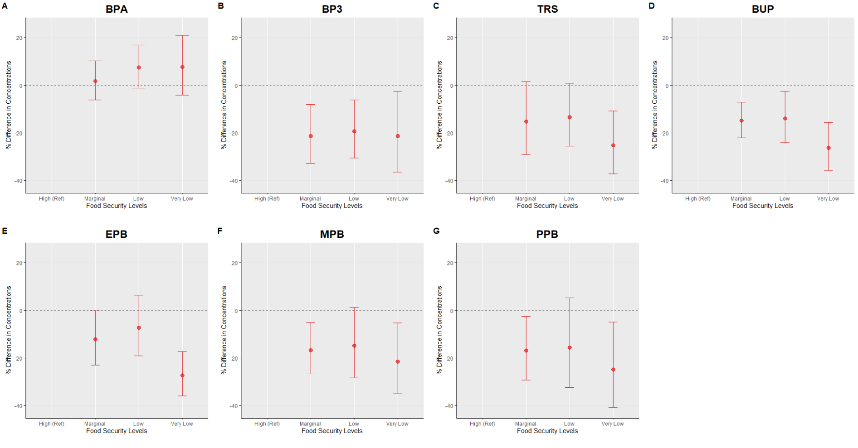
- Panels A–G represent adjusted percent differences in urinary phenol metabolite concentrations. Reference is High Food Secure. Circles represent estimated percent differences; bars represent 95% confidence intervals. All models are adjusted for age, sex education, race/ethnicity, poverty-income ratio, cycle year, and creatinine.

Figure 2: Strata Specific Adjusted Linear Regression Plot: Self-Reported Food Security Status and Urinary Phenol Metabolites with Sex Interaction
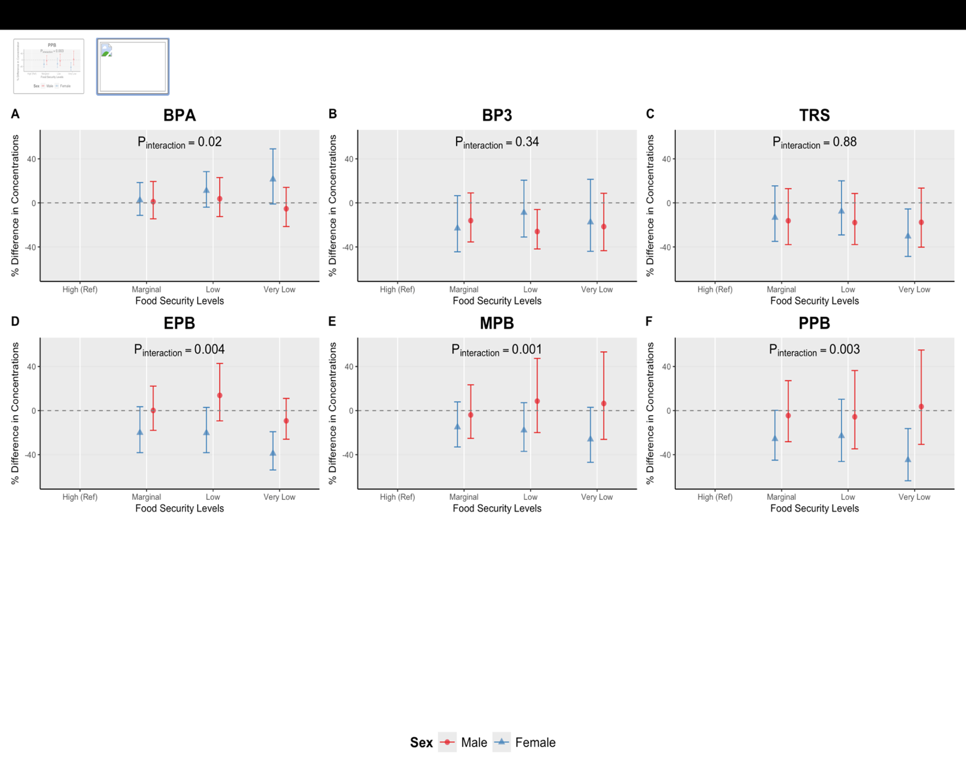
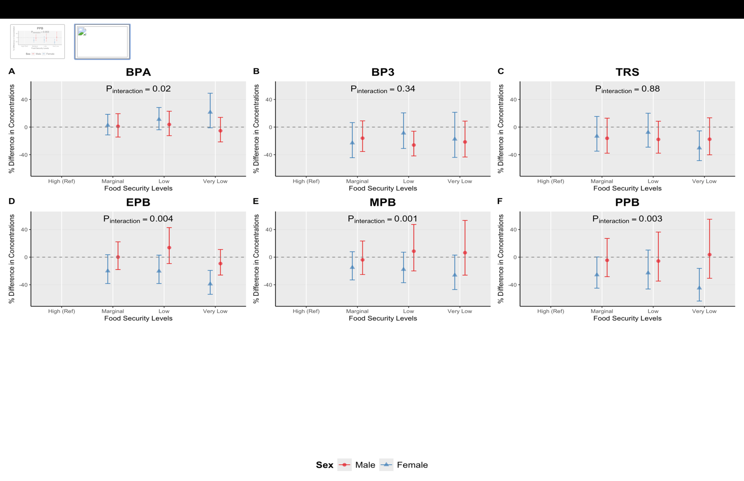
- Sex stratified adjusted percent differences (95% confidence intervals) in urinary phenol metabolite
- Concentrations across food security levels, estmated from multivariable linear regression models adjusted for age, race and ethnicity, education, survey cycle, poverty:income ratio and creatinine. High Food Secure is the reference group.
- P_{interaction} values are reported from food security*sex interaction models, where food security is modeled as continuous variable.

Effect Measure Modification by Sex
Next, we assessed potential effect measure modification by sex. There was evidence of interaction for BPA (p_{interaction}=0.02), and all parabens (ethyl (p_{interaction}<0.01), methyl (p_{interaction} <0.01), propyl (p_{interaction}<0.01). In stratum specific models, we estimated marginal means and reported percent differences.
For BPA estimates, both females and males exhibited positive differences with reduced food security exposure, although the association appeared to be slightly stronger among females. Specifically, females experiencing low (1.08%; [95% CI: -3.9%, 28.41%]); and very low food security (very low: 21.45%; [95% CI: -1.04%, 49.05%]) had higher BPA concentrations compared with females with high food security. Among males, estimates hovered around the null and were slightly lower among very low males (-5.35%; [95% CI: -21.46%, 14.06%]). compared to males experiencing high food security (Figure 2, Supplemental Table 2).
Percent differences for parabens remained mostly negative within stratum of sex, and associations were stronger amongst females. Among females experiencing high food security, ethyl paraben concentrations were lower for marginal (20.04% [95% CI: −38.24%, −3.51%]); low (20.29% [95% CI: −38.25%, −2.89%]) and very low (38.94% [95% CI: −53.86%, −19.21%]) food secure females. Similar trends were observed for methyl paraben (marginal: -14.99%; [95% CI:-33.01%, 7.87%]; low: -17.85%; [95% CI: -37.03%, 7.18%]; very low: -26.10%; [95 CI: -46.97%, 2.98%]), and propyl paraben (marginal: (-25.71%; [95% CI:-44.96%, 0.27%%]; low: -22.96%; [95% CI: -46.20%, 10.31%]; very low: -44.82%; [95 CI: -63.63%, 16.28%]). In contrast, among males with some but not all reduced food security categories, higher levels were observed for ethyl (low: 13.79%; [95% CI: -9.33%, 42.78%]), and methyl paraben (low: 8.59%, [95% CI: -19.99%, 47.37%; very low: 6.41% [95% CI: -26.1%, 53.22%]) relative to the reference. (Figure 2, Supplemental Table 2)

Figure 3: Strata-Specific Adjusted Linear Regression Plot: Self-Reported Food Security Status and Urinary Phenol Metabolites with Race and Ethnicity Interaction 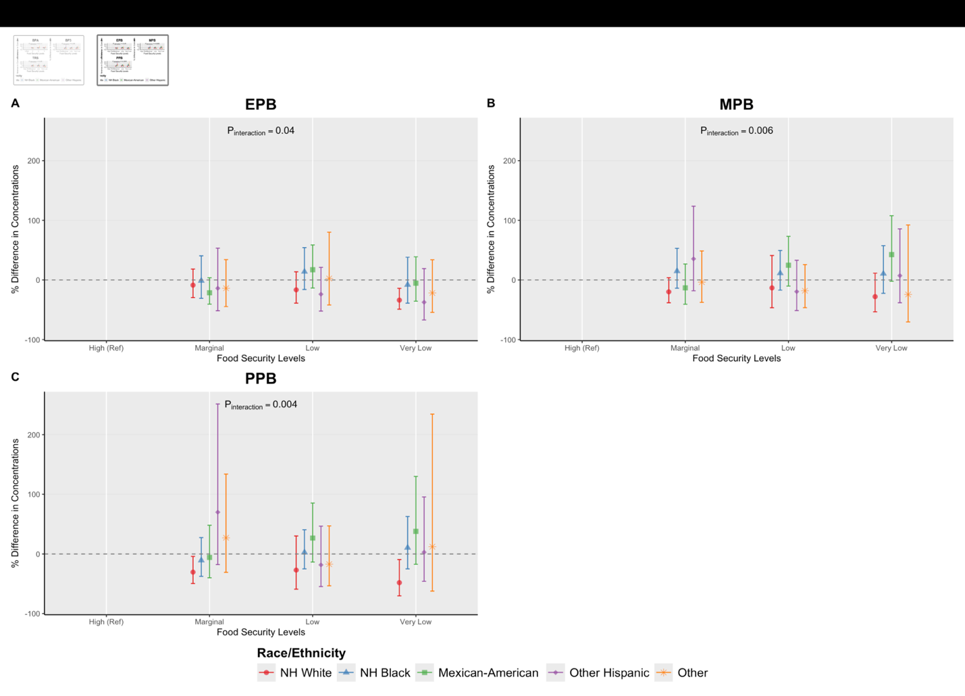
- Race stratified adjusted percent differences (95% confidence intervals) in urinary phenol metabolite concentrations across food security levels, estmated from multivariable linear regression models adjusted for age, sex, education, survey cycle, poverty:income ratio and creatinine. High Food Secure is the reference group.
- P_{interaction} values are reported from food security*race and ethnicity interaction models, where food security is modeled as continuous variable.
- NH White: Non Hispanic White; NH Black: Non-Hispanic Black

Effect Measure Modification by Race/Ethnicity
Finally, we assessed potential effect measure modification by race and ethnicity (Supplemental Tables 3-9). There was evidence of interaction all parabens, ethyl (p_{interaction}=0.04), methyl (p_{interaction}<0.01), and propyl (p_{interaction} <0.01). Among non-Hispanic White individuals, reduced food security (marginal, low, and very low) was associated with lower levels of parabens. Non-Hispanic White individuals experiencing very low food secure participants had the largest negative difference (i.e. lowest levels) compared to non-Hispanic White adults with high food security (e.g. ethyl paraben concentrations: very low: -33.81% [95% CI: -49.12%, -13.90%]).
In contrast, Mexican-American participants experiencing low or very low food security generally had higher levels of parabens. For instance, relative to Mexican-Americans with high food security, methyl parabens estimates were lower among Mexican-Americans experiencing low (24.69% [95% CI: -10.20,73.13%]) and lower among those experiencing very low food security (42.53% 95% CI [-2.18, 107.69%]) (Figure 3, Supplemental Table 8). Among non-Hispanic Black individuals’ results were similar to those among non-Hispanic Black adults with low food security generally showing the largest positive percent difference for ethyl (low: 13.88% [95% CI: -15.89%, 54.18%) (Figure 3, Supplemental 7) methyl (low: 11.32% [95% CI: -17.07%, 49.43%]) (Figure 3, Supplemental 8) and propyl (low: 2.65% [95% CI: -15.89%, 54.18%]; very low: 10.44% [95% CI: -25.02%, 62.29%]) (Figure 3, Supplemental 9) parabens. Among other Hispanic and Other-race adults, associations between reduced food security and paraben concentrations appeared to be positive for some, but not all parabens; however, results were mixed overall.

